VENANGO TECHNOLOGY CENTER
JOINT COMMITTEE
1 Vo-Tech Drive
Oil City, Pennsylvania 16301

MINUTES

February 7, 2022

The regular meeting of the Venango Technology Center Joint Committee was held this evening in the Conference Room of the Venango Technology Center, 1 Vo-Tech Drive, Oil City, PA 16301. Mr. Carson called the meeting to order at seven o’clock (7:00) p.m.

Mr. Carson asked the members to pause for a moment of silence.

Mr. Carson asked the members to stand for the pledge of allegiance.

Roll Call: Present: Jeff Thomas (zoom), Andy Boland, Shari Neely, Lynn Cressman, Stephen Kelley,
Ben Carbaugh, Don Judy (zoom), Todd Carson

Absent: Mark Marterella, Troy Johnston

Also Present: Mr. Mario Fontanazza, Mr. Kevin Briggs (zoom)

Mr. Carson stated the Joint Committee members had received copies of the Minutes of the January 3, 2022 meeting in the mail. He asked if there were any additions, corrections or deletions.

Mrs. Neely, seconded by Mr. Kelley, moved to approve the Minutes of the January 3, 2022 meeting as submitted.

Roll Call: Ayes: Jeff Thomas, Andy Boland, Shari Neely, Lynn Cressman, Stephen Kelley,
Ben Carbaugh, Don Judy, Todd Carson

Nayes: None, motion carried.

The Treasurer and Secretary’s Report as of 2/7/22 were submitted for information.

Mrs. Neely, seconded by Mrs. Cressman, moved to accept the Treasurer and Secretary’s Report as of 2/7/22 as submitted.

The motion was unanimously approved.

A list of bills from 1/4/22 – 2/7/22 in the amount of $620,701.17 was presented for approval.

Mrs. Neely, seconded by Mr. Kelley, moved to approve the list of bills as presented.

Roll Call: Ayes: Jeff Thomas, Andy Boland, Shari Neely, Lynn Cressman, Stephen Kelley,
Ben Carbaugh, Don Judy, Todd Carson

Nayes: None, motion carried.

Under Communications, Mr. Fontanazza discussed the Professional Advisory Committee. He also discussed the Calendar of Events for the month of January and the Monthly Enrollment Report as of 2/7/22 were submitted.

Mr. Carson requested approval of the action items as presented. Item 8. a) ii.- iii. in one motion.

Mr. Carson, seconded by Mr. Thomas, moved to approve action items ii.- iii. as follows:

- Approve additions to Occupational Advisory Committees.
- Approve contract with CCS renovations for construction of the Arch building for $21,250.00.
- Approve update to the Venango Technology Center Health and Safety Plan.

Roll Call: Ayes: Jeff Thomas, Andy Boland, Shari Neely, Lynn Cressman, Stephen Kelley,
Ben Carbaugh, Don Judy, Todd Carson

Nayes: None, motion carried.

Mr. Fontanazza reviewed his Issues/Activities for January 2022.

Mr. Bob Moore, Cooperative Education Coordinator, reported on the competition at Skills USA. He indicated that we received 6 gold medal, 9 silver medals and 9 bronze medals.

Mr. Adams reported the results on voting for the Venango Technology Center 2022-2023 budget.

Mr. Carson asked if there was any old business.

None was noted.

Mr. Carson asked if there was any new business.

None was noted.

Upon motion by Mrs. Neely, seconded by Mrs. Cressman, the meeting adjourned at twenty four minutes past seven (7:24) p.m.

Recorded by
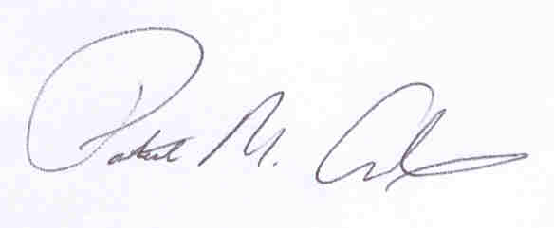
Patrick M. Adams
Secretary, Joint Committee

